

Outer Carton Shipping Label (for EDI Compliant vendors)

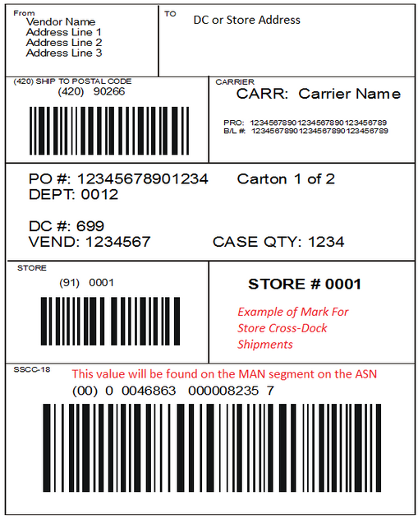
Ship to address for Hibbett warehouse

Purchase order number contained in box

Barcode indicating the carton ID. This same ID number should be transmitted in the MAN segment, element 02 of the ASN (856)
Carrier Info (optional)
HIBBETT WHOLESALE
Warehouse Address Line 1
Warehouse Address Line 2
0001

Hibbett destination store number; Max.4 digits, min. 3 digits

